COMMITTEE AND MANAGER REPORT JULY 2019

Swimming Pool
The pool area has been upgraded. We plan to convert to a salt-water pool.
This was a big repair job including the shower rooms, plumbing, electrics and roof. We re-installed the kids' slide and the waterfall
The upgrade is not finished. We will add palm trees, plants and more furniture and install free Wi-Fi.

Ceilings / lights / painting
All the ceilings will be repaired this year for reasons of safety. We are running a new live cable for the lights, re-routing all the wiring and removing old wiring.
All the corridors will be painted and have LED lights

Digital TV
Everyone should be using the 130 digital channels from Sophon. If you have an old analog TV, the manager will show you how to convert.

Fibre optic internet
TOT have installed fibre optic. The cost is about 500 baht per month for 50Mbps if you pay a year in advance. Owners have said it is fast and reliable.
Maximum speeds are 200 Mbps and cost about 900 baht per month.

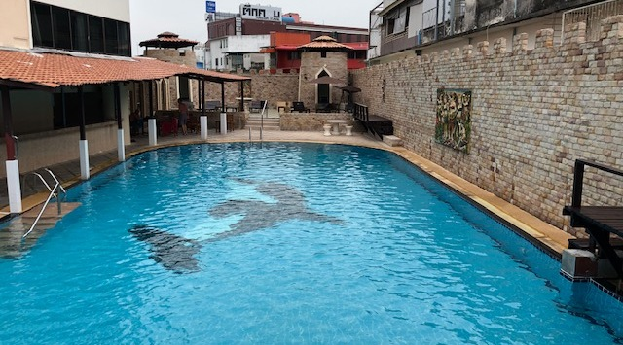 | 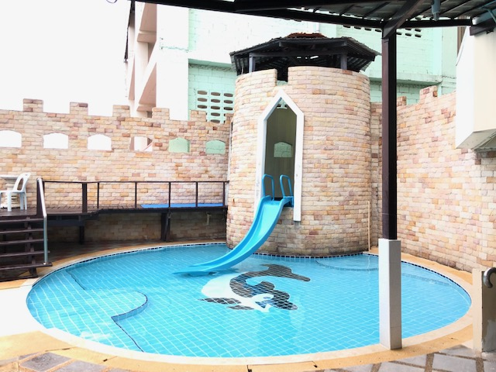
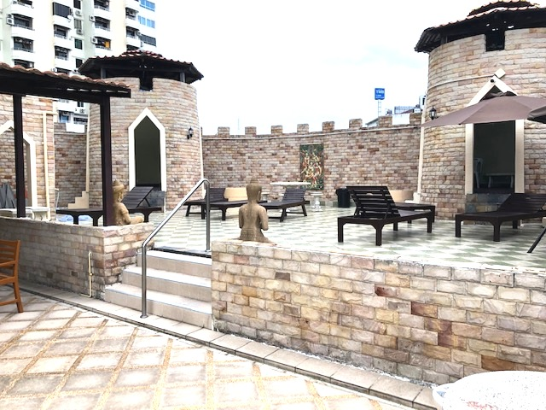 | 